|  |
| --- |
| ***KITAB 360*** |

Aim :- To create a FullStack Web-App for the book management and recommendation

Overview

the user has the following options:

* Add book information.
* Display book information.
* To list all books of a given author.
* To list the count of books in the library.

**Functionalities Required:**

* If the user tries to add a book then the user must have to provide the below specific Information about the book as:
  + Enter Book Name:
  + Enter Author Name:
  + Enter Pages:
  + Enter Price:
* When the user tries to display all books of a particular author then the user must have to enter the name of the author:
  + Enter the author name:
* The E-Library management System must be also capable of counting all the books available in the library.

TECHNOLOGY USED

Frontend:- HTML,CSS,JAVASCRIPT,BOOTSTRAP.

Backend:- MongoDb,Node.js,EXPRESS.JS

SAMPLE FRONT END DESIGNS

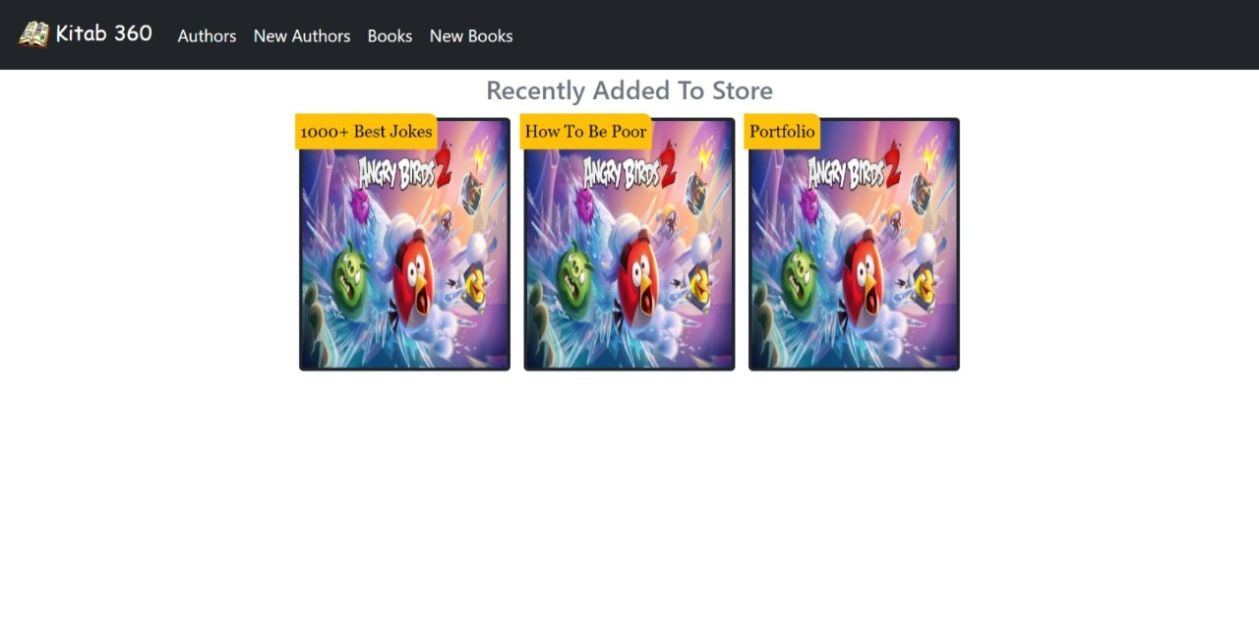

Search Author

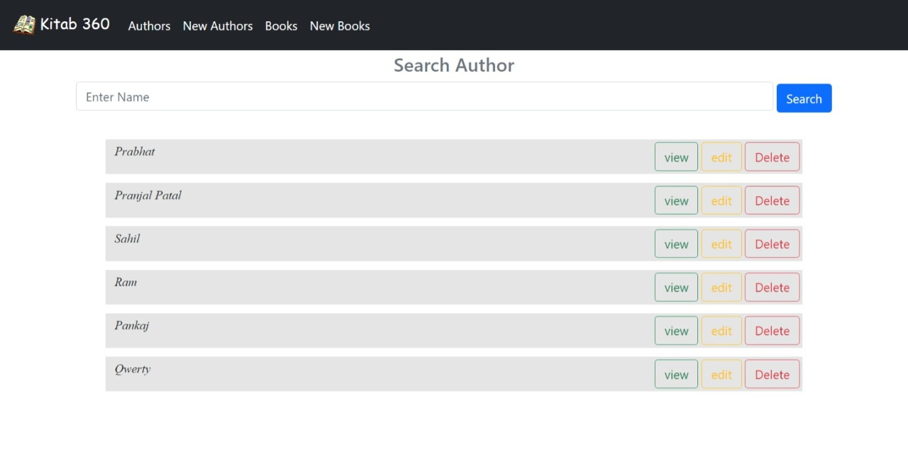

Add New Authors

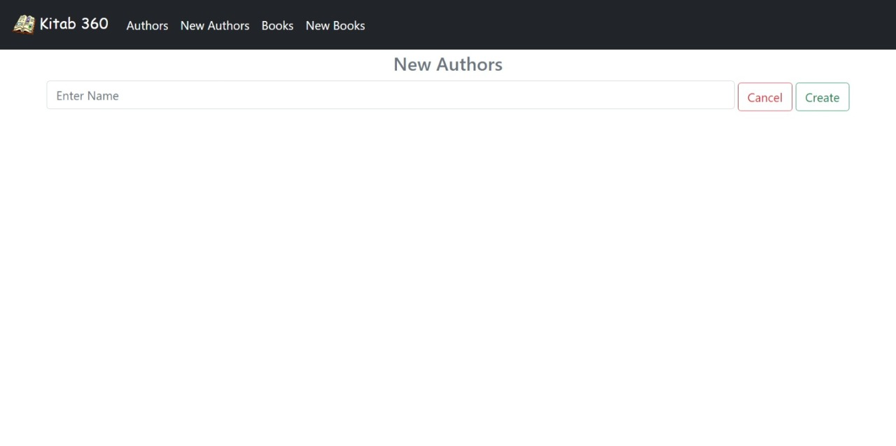

Search Book

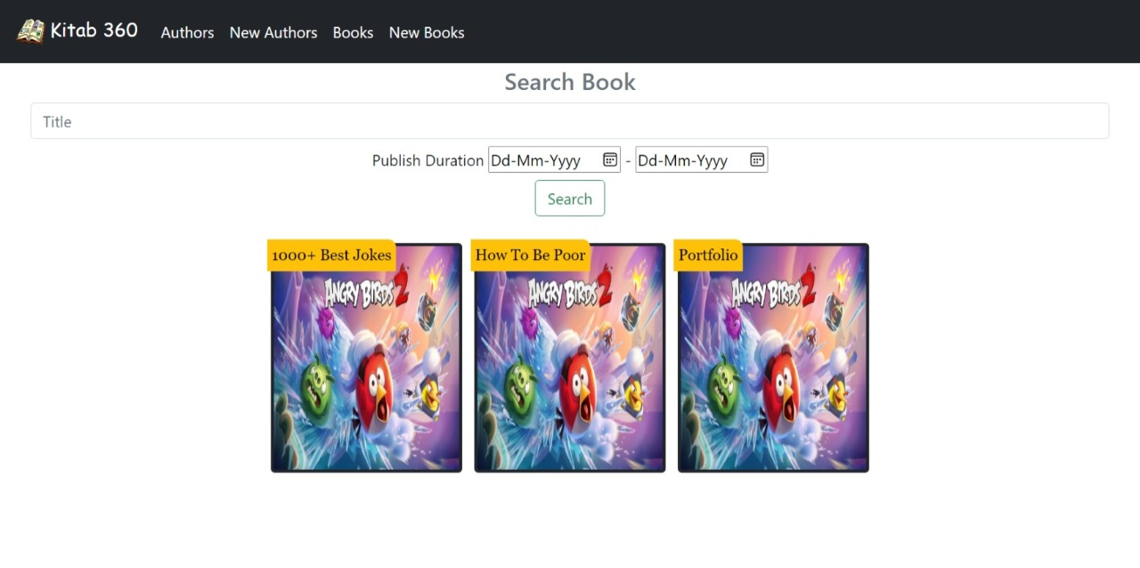

Add New Book

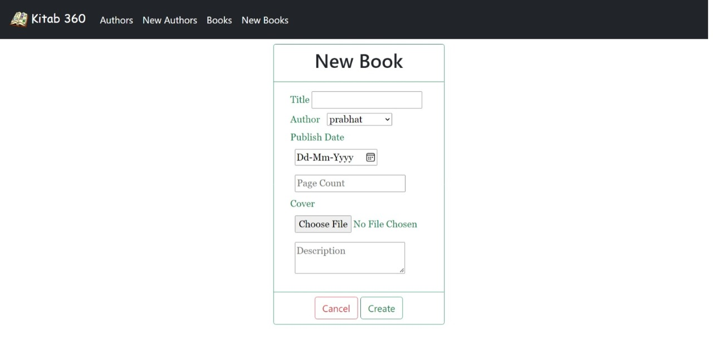

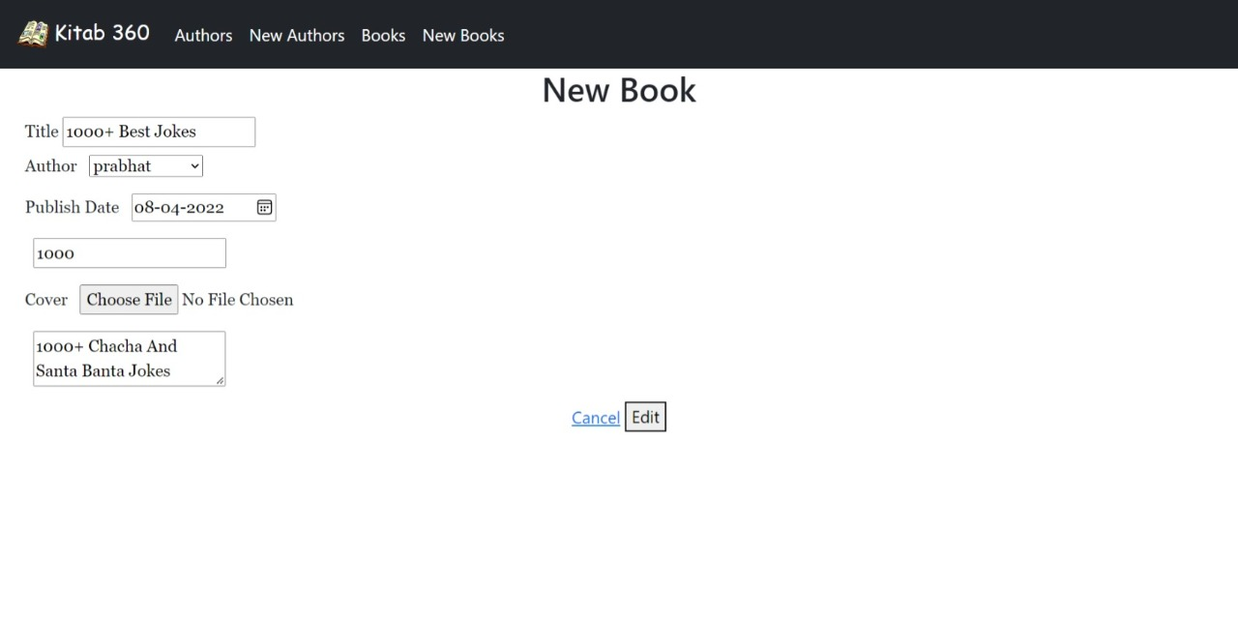Books by Authors

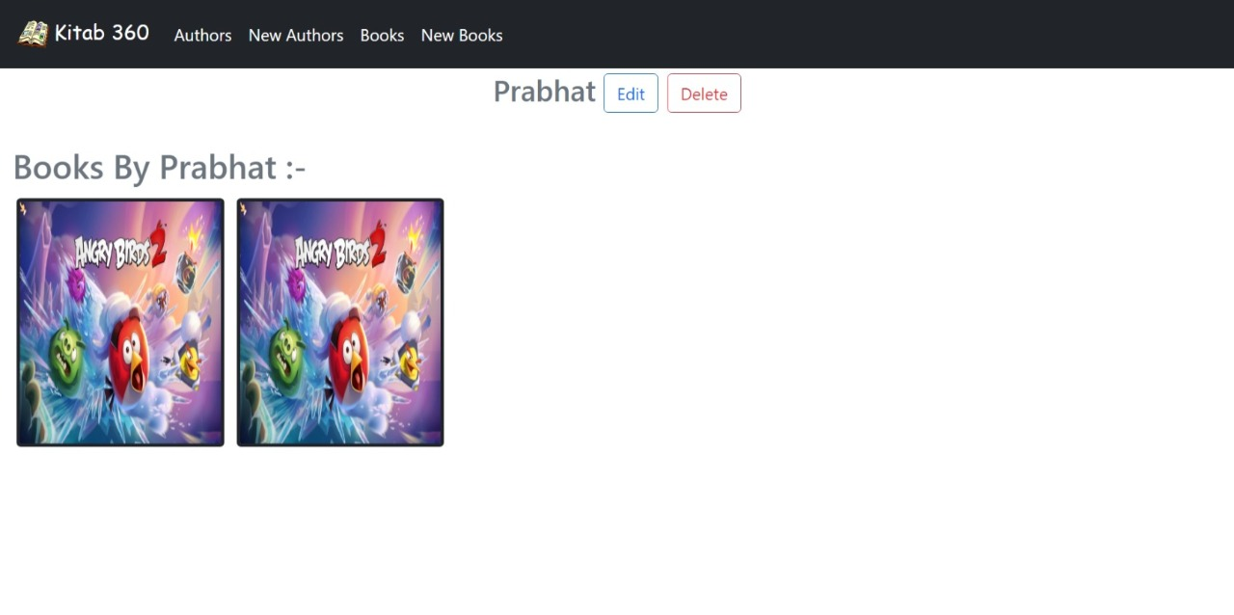

Update Author

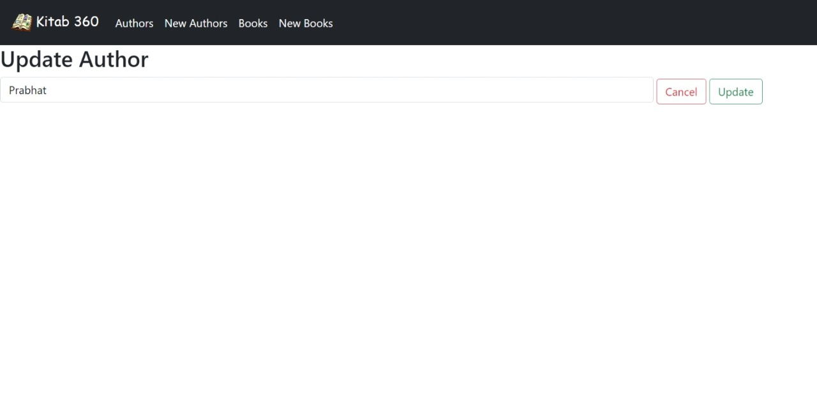

Book and Author Details

